REVIEW- Grade 3
NAME: .............................

Part 1
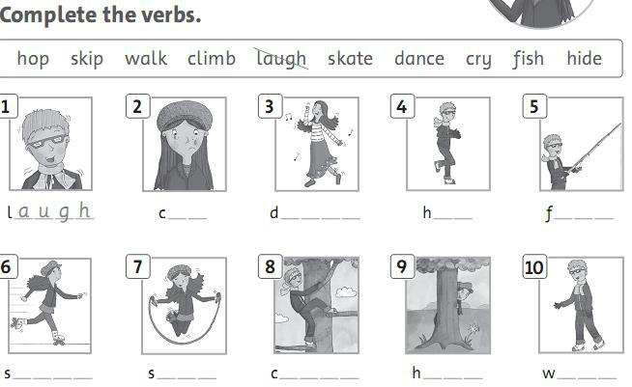

Part 2: Write the words
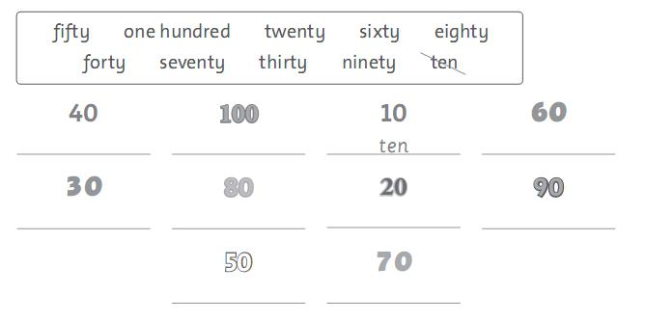

G3-review.1-TBT Page 1 of 4
Part 3:
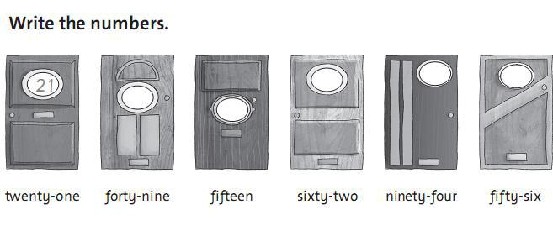

Part 4:
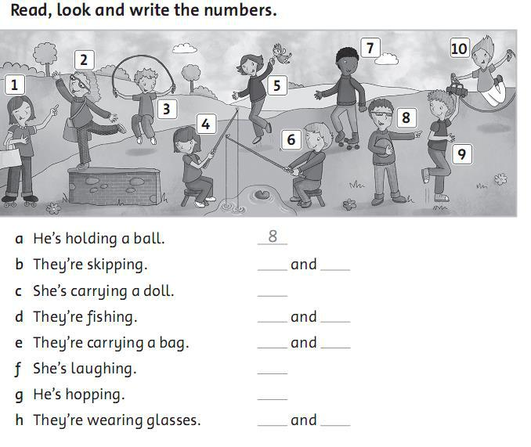

Part 5: How many are there? Look and write

G3-review.1-TBT Page 2 of 4
Part 5:
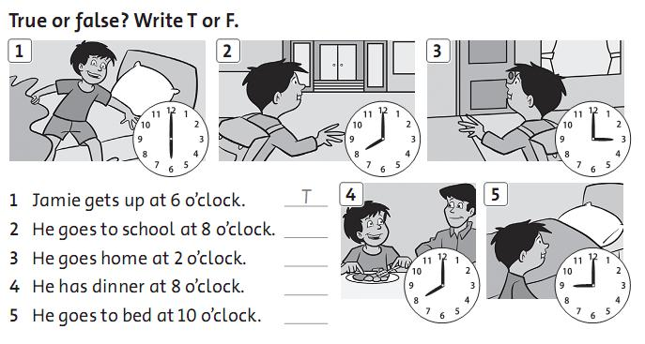

Part 6
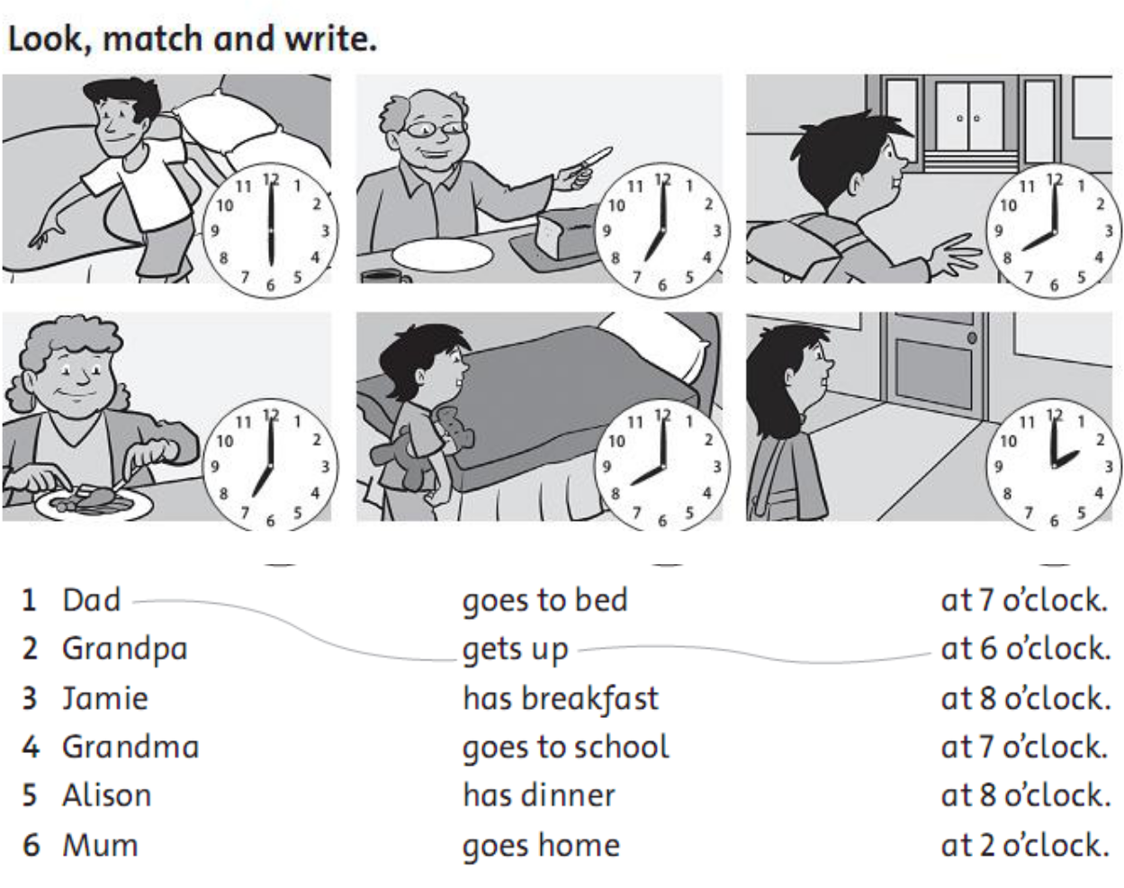

G3-review.1-TBT Page 3 of 4
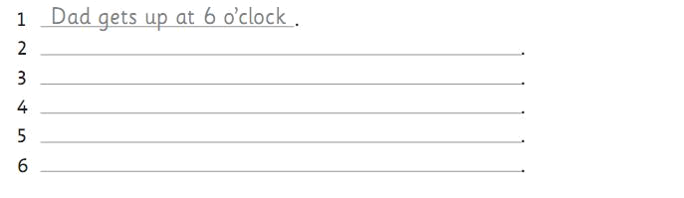

Part 7
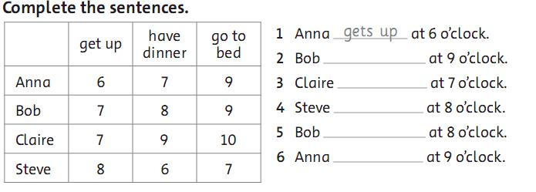

Part 8:
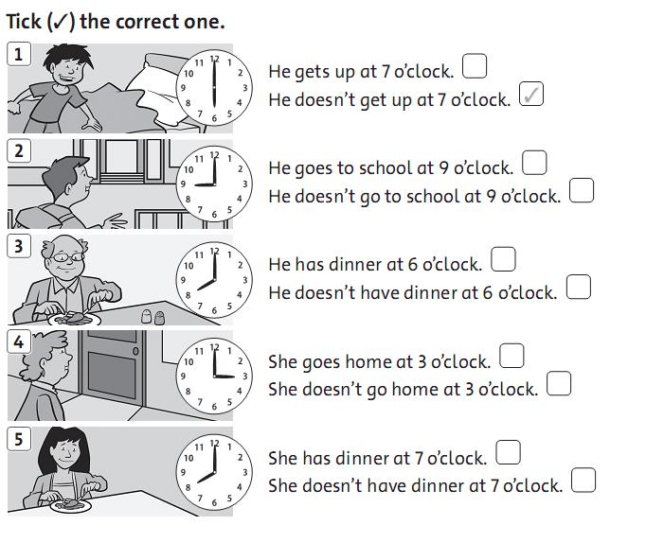

G3-review.1-TBT Page 4 of 4

